Why String is Immutable or Final in Java
The string is Immutable in Java because String objects are cached in String pool. Since cached String literals are shared between multiple clients there is always a risk, where one client's action would affect all another client. For example, if one client changes the value of String "Test" to "TEST", all other clients will also see that value as explained in the first example. Since caching of String objects was important from performance reason this risk was avoided by making String class Immutable. At the same time, String was made final so that no one can compromise invariant of String class e.g. Immutability, Caching, hashcode calculation etc by extending and overriding behaviors. Another reason of why String class is immutable could die due to HashMap.
Since Strings are very popular as HashMap key, it's important for them to be immutable so that they can retrieve the value object which was stored in HashMap. Since HashMap works in the principle of hashing, which requires same has value to function properly. Mutable String would produce two different hashcodes at the time of insertion and retrieval if contents of String was modified after insertion, potentially losing the value object in the map.
If you are an Indian cricket fan, you may be able to correlate with my next sentence. The string is VVS Laxman of Java, i.e. very very special class. I have not seen a single Java program which is written without using String. That's why a solid understanding of String is very important for a Java developer.

Important and popularity of String as data type, transfer object and mediator has also made it popular in Java interviews. Why String is immutable in Java is one of the most frequently asked String Interview questions in Java, which starts with discussion of, what is String, how String in Java is different than String in C and C++, and then shifted towards what is immutable object in Java , what are the benefits of immutable object, why do you use them and which scenarios should you use them. This question sometimes also asked, "Why String is final in Java".
On a similar note, if you are preparing for Java interviews, I would suggest you take a loot at the Java Programming interview exposed book, an excellent resource for senior and mid-level Java programmer. It contains questions from all important Java topic including multi-threading, collection, GC, JVM internals and framework like Spring and Hibernate, as shown below:

Why String is Final in Java
As I said, there could be many possible answers to this question, and the only designer of String class can answer it with confidence. I was expecting some clue in Joshua Bloch's Effective Java book, but he also didn't mention it. I think following two reasons make a lot of sense on why String class is made Immutable or final in Java: 1) Imagine String pool facility without making string immutable , its not possible at all because in case of string pool one string object/literal e.g. "Test" has referenced by many reference variables, so if any one of them change the value others will be automatically gets affected i.e. lets say
String A = "Test"
String B = "Test"
Now String B called, "Test".toUpperCase() which change the same object into "TEST", so A will also be "TEST" which is not desirable. Here is a nice diagram which shows how String literals are created in heap memory and String literal pool.
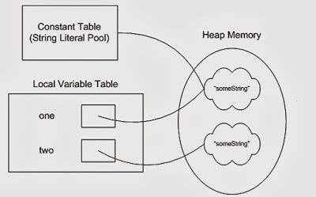
2) String has been widely used as parameter for many Java classes e.g. for opening network connection, you can pass hostname and port number as string, you can pass database URL as a string for opening database connection, you can open any file in Java by passing the name of the file as argument to File I/O classes.
In case, if String is not immutable, this would lead serious security threat, I mean someone can access to any file for which he has authorization, and then can change the file name either deliberately or accidentally and gain access to that file. Because of immutability, you don't need to worry about that kind of threats. This reason also gels with, Why String is final in Java, by making java.lang.String final, Java designer ensured that no one overrides any behavior of String class.

3)Since String is immutable it can safely share between many threads which is very important for multithreaded programming and to avoid any synchronization issues in Java, Immutability also makes String instance thread-safe in Java, means you don't need to synchronize String operation externally. Another important point to note about String is the memory leak caused by SubString, which is not a thread related issues but something to be aware of.
4) Another reason of Why String is immutable in Java is to allow String to cache its hashcode, being immutable String in Java caches its hashcode, and do not calculate every time we call hashcode method of String, which makes it very fast as hashmap key to be used in hashmap in Java. This one is also suggested by Jaroslav Sedlacek in comments below. In short because String is immutable, no one can change its contents once created which guarantees hashCode of String to be same on multiple invocations.
5) Another good reason of Why String is immutable in Java suggested by Dan Bergh Johnsson on comments is: The absolutely most important reason that String is immutable is that it is used by the class loading mechanism, and thus have profound and fundamental security aspects. Had String been mutable, a request to load "java.io.Writer" could have been changed to load "mil.vogoon.DiskErasingWriter"
Security and String pool being primary reason of making String immutable, I believe there could be some more very convincing reasons as well, Please post those reasons as comments and I will include those on this post. By the way, above reason holds good to answer, another Java interview questions "Why String is final in Java". Also to be immutable you have to be final so that your subclass doesn't break immutability. what do you guys think?

Immutable String in Java
In java, string objects are immutable. Immutable simply means unmodifiable or unchangeable.
Once string object is created its data or state can't be changed but a new string object is created.
Let's try to understand the immutability concept by the example given below:
- class Testimmutablestring{
- public static void main(String args[]){
- String s="Sachin";
- s.concat(" Tendulkar");//concat() method appends the string at the end
- System.out.println(s);//will print Sachin because strings are immutable objects
- }
- }
Test it Now
Output:Sachin
Now it can be understood by the diagram given below. Here Sachin is not changed but a new object is created with sachintendulkar. That is why string is known as immutable.
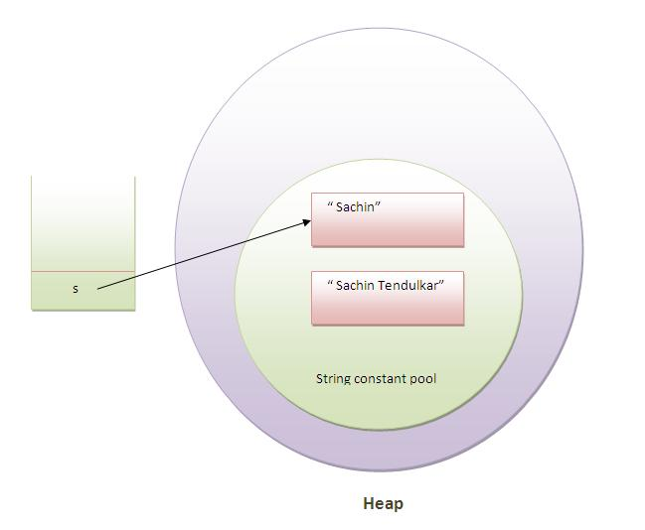
As you can see in the above figure that two objects are created but s reference variable still refers to "Sachin" not to "Sachin Tendulkar".
But if we explicitely assign it to the reference variable, it will refer to "Sachin Tendulkar" object.For example:
- class Testimmutablestring1{
- public static void main(String args[]){
- String s="Sachin";
- s=s.concat(" Tendulkar");
- System.out.println(s);
- }
- }
Test it Now
Output:Sachin Tendulkar
In such case, s points to the "Sachin Tendulkar". Please notice that still sachin object is not modified.

Why string objects are immutable in java?
Because java uses the concept of string literal.Suppose there are 5 reference variables,all referes to one object "sachin".If one reference variable changes the value of the object, it will be affected to all the reference variables. That is why string objects are immutable in java.

Why String is immutable in Java ?

String is an immutable class in Java. An immutable class is simply a class whose instances cannot be modified. All information in an instance is initialized when the instance is created and the information can not be modified. There are many advantages of immutable classes. This article summarizes why String is designed to be immutable. A good answer depends on the deep understanding of memory, synchronization, data structures, etc.
1. Requirement of String Pool
String pool (String intern pool) is a special storage area in Method Area. When a string is created and if the string already exists in the pool, the reference of the existing string will be returned, instead of creating a new object and returning its reference.
The following code will create only one string object in the heap.
String string1 = "abcd";
String string2 = "abcd";
Here is how it looks:
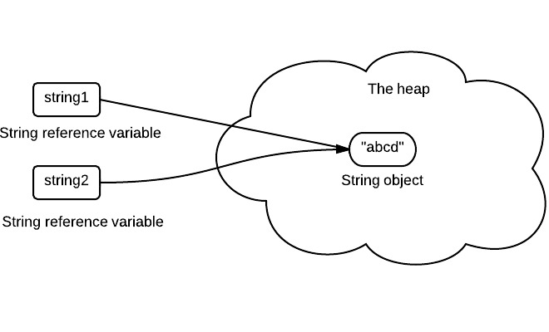
If a string is not immutable, changing the string with one reference will lead to the wrong value for the other references.
2. Caching Hashcode
The hashcode of the string is frequently used in Java. For example, in a HashMap. Being immutable guarantees that hashcode will always the same so that it can be cashed without worrying the changes.That means, there is no need to calculate hashcode every time it is used. This is more efficient.
In String class, it has the following code:
private int hash;//this is used to cache hash code.
3. Facilitating the Use of Other Objects
To make this concrete, consider the following program:
HashSet<String> set = new HashSet<String>();
set.add(new String("a"));
set.add(new String("b"));
set.add(new String("c"));

for(String a: set)
a.value = "a";
In this example, if String is mutable, it's value can be changed which would violate the design of set (set contains unduplicated elements). This example is designed for simplicity sake, in the real String class there is no value field.
4. Security
String is widely used as a parameter for many java classes, e.g. network connection, opening files, etc. Were String not immutable, a connection or file would be changed and lead to a serious security threat. The method thought it was connecting to one machine, but was not. Mutable strings could cause a security problem in Reflection too, as the parameters are strings.
Here is a code example:
boolean connect(string s){
if (!isSecure(s)) {
throw new SecurityException();
}
//here will cause problem, if s is changed before this by using other references.
causeProblem(s);
}
5. Immutable objects are naturally thread-safe
Because immutable objects can not be changed, they can be shared among multiple threads freely. This eliminates the requirements of doing synchronization.
In summary, String is designed to be immutable for the sake of efficiency and security. This is also the reason why immutable classes are preferred in general.

Build a REST API with Spring 4 and Java Config
Last modified: October 18, 2016
REST, SPRING
by
Eugen Paraschiv

I just announced the Master Class of my "REST With Spring" Course:
>> THE "REST WITH SPRING" CLASSES

Table of Contents
- 1. Overview
- 2. Understanding REST in Spring
- 3. The Java configuration
- 4. Testing the Spring context
- 5. The Controller
- 6. Mapping the HTTP response codes
- 6.1. Unmapped requests
- 6.2. Valid, mapped requests
- 6.3. Client error
- 6.4. Using @ExceptionHandler
- 7. Additional Maven dependencies
- 8. Conclusion

1. Overview
This article shows how to set up REST in Spring – the Controller and HTTP response codes, configuration of payload marshalling and content negotiation.

2. Understanding REST in Spring
The Spring framework supports 2 ways of creating RESTful services:
- using MVC with ModelAndView
- using HTTP message converters
The ModelAndView approach is older and much better documented, but also more verbose and configuration heavy. It tries to shoehorn the REST paradigm into the old model, which is not without problems. The Spring team understood this and provided first-class REST support starting with Spring 3.0.
The new approach, based on HttpMessageConverter and annotations, is much more lightweight and easy to implement. Configuration is minimal and it provides sensible defaults for what you would expect from a RESTful service. It is, however, newer and a bit on the light side concerning documentation; what’s , the reference doesn’t go out of its way to make the distinction and the tradeoffs between the two approaches as clear as they should be. Nevertheless, this is the way RESTful services should be built after Spring 3.0.

3. The Java configuration

1  2  3  4  5 | @Configuration  @EnableWebMvc  public class WebConfig{  //  }
The new @EnableWebMvc annotation does a number of useful things – specifically, in the case of REST, it detects the existence of Jackson and JAXB 2 on the classpath and automatically creates and registers default JSON and XML converters. The functionality of the annotation is equivalent to the XML version:
<mvc:annotation-driven />
This is a shortcut, and though it may be useful in many situations, it’s not perfect. When more complex configuration is needed, remove the annotation and extend WebMvcConfigurationSupport directly.

4. Testing the Spring context
Starting with Spring 3.1, we get first-class testing support for @Configurationclasses:
1  2  3  4  5  6  7  8  9  10 | @RunWith( SpringJUnit4ClassRunner.class )  @ContextConfiguration( classes = { ApplicationConfig.class, PersistenceConfig.class },  loader = AnnotationConfigContextLoader.class )  public class SpringTest{  @Test  public void whenSpringContextIsInstantiated_thenNoExceptions(){  // When  }  }
The Java configuration classes are simply specified with the @ContextConfiguration annotation and the new AnnotationConfigContextLoaderloads the bean definitions from the @Configuration classes.
Notice that the WebConfig configuration class was not included in the test because it needs to run in a Servlet context, which is not provided.

5. The Controller
The @Controller is the central artifact in the entire Web Tier of the RESTful API. For the purpose of this post, the controller is modeling a simple REST resource – Foo:
1  2  3  4  5  6  7  8  9  10  11  12  13  14  15  16  17  18  19  20  21  22  23  24  25  26  27  28  29  30  31  32  33  34  35  36  37  38  39  40  41  42 | @Controller  @RequestMapping( value = "/foos" )  class FooController{  @Autowired  IFooService service;  @RequestMapping( method = RequestMethod.GET )  @ResponseBody  public List< Foo > findAll(){  return service.findAll();  }  @RequestMapping( value = "/{id}", method = RequestMethod.GET )  @ResponseBody  public Foo findOne( @PathVariable( "id" ) Long id ){  return RestPreconditions.checkFound( service.findOne( id ) );  }  @RequestMapping( method = RequestMethod.POST )  @ResponseStatus( HttpStatus.CREATED )  @ResponseBody  public Long create( @RequestBody Foo resource ){  Preconditions.checkNotNull( resource );  return service.create( resource );  }  @RequestMapping( value = "/{id}", method = RequestMethod.PUT )  @ResponseStatus( HttpStatus.OK )  public void update( @PathVariable( "id" ) Long id, @RequestBody Foo resource ){  Preconditions.checkNotNull( resource );  RestPreconditions.checkNotNull( service.getById( resource.getId() ) );  service.update( resource );  }  @RequestMapping( value = "/{id}", method = RequestMethod.DELETE )  @ResponseStatus( HttpStatus.OK )  public void delete( @PathVariable( "id" ) Long id ){  service.deleteById( id );  }  }
You may have noticed I’m using a very simple, guava style RestPreconditionsutility:
1  2  3  4  5  6  7  8 | public class RestPreconditions {  public static <T> T checkFound(final T resource) {  if (resource == null) {  throw new MyResourceNotFoundException();  }  return resource;  }  }
The Controller implementation is non-public – this is because it doesn’t need to be. Usually, the controller is the last in the chain of dependencies – it receives HTTP requests from the Spring front controller (the DispathcerServlet) and simply delegates them forward to a service layer. If there is no use case where the controller has to be injected or manipulated through a direct reference, then I prefer not to declare it as public.
The request mappings are straightforward – as with any controller, the actual value of the mapping as well as the HTTP method are used to determine the target method for the request. @RequestBody will bind the parameters of the method to the body of the HTTP request, whereas @ResponseBody does the same for the response and return type. They also ensure that the resource will be marshalled and unmarshalled using the correct HTTP converter. Content negotiation will take place to choose which one of the active converters will be used, based mostly on the Accept header, although other HTTP headers may be used to determine the representation as well.

6. Mapping the HTTP response codes
The status codes of the HTTP response are one of the most important parts of the REST service, and the subject can quickly become very complex. Getting these right can be what makes or breaks the service.

6.1. Unmapped requests
If Spring MVC receives a request which doesn’t have a mapping, it considers the request not to be allowed and returns a 405 METHOD NOT ALLOWED back to the client. It is also good practice to include the Allow HTTP header when returning a 405 to the client, in order to specify which operations are allowed. This is the standard behavior of Spring MVC and does not require any additional configuration.

6.2. Valid, mapped requests
For any request that does have a mapping, Spring MVC considers the request valid and responds with 200 OK if no other status code is specified otherwise. It is because of this that controller declares different @ResponseStatus for the create, update and delete actions but not for get, which should indeed return the default 200 OK.

6.3. Client error
In case of a client error, custom exceptions are defined and mapped to the appropriate error codes. Simply throwing these exceptions from any of the layers of the web tier will ensure Spring maps the corresponding status code on the HTTP response.
1  2  3  4  5  6  7  8 | @ResponseStatus( value = HttpStatus.BAD_REQUEST )  public class BadRequestException extends RuntimeException{  //  }  @ResponseStatus( value = HttpStatus.NOT_FOUND )  public class ResourceNotFoundException extends RuntimeException{  //  }
These exceptions are part of the REST API and, as such, should only be used in the appropriate layers corresponding to REST; if for instance a DAO/DAL layer exist, it should not use the exceptions directly. Note also that these are not checked exceptions but runtime exceptions – in line with Spring practices and idioms.

6.4. Using @ExceptionHandler
Another option to map custom exceptions on specific status codes is to use the @ExceptionHandler annotation in the controller. The problem with that approach is that the annotation only applies to the controller in which it is defined, not to the entire Spring Container, which means that it needs to be declared in each controller individually. This quickly becomes cumbersome, especially in more complex applications which many controllers. There are a few JIRA issues opened with Spring at this time to handle this and other related limitations: SPR-8124, SPR-7278, SPR-8406.

7. Additional Maven dependencies
In addition to the spring-webmvc dependency required for the standard web application, we’ll need to set up content marshalling and unmarshalling for the REST API:
1  2  3  4  5  6  7  8  9  10  11  12  13  14  15  16  17  18 | <dependencies>  <dependency>  <groupId>com.fasterxml.jackson.core</groupId>  <artifactId>jackson-databind</artifactId>  <version>${jackson.version}</version>  </dependency>  <dependency>  <groupId>javax.xml.bind</groupId>  <artifactId>jaxb-api</artifactId>  <version>${jaxb-api.version}</version>  <scope>runtime</scope>  </dependency>  </dependencies>  <properties>  <jackson.version>2.4.0</jackson.version>  <jaxb-api.version>2.2.11</jaxb-api.version>  </properties>
These are the libraries used to convert the representation of the REST resource to either JSON or XML.

8. Conclusion
This tutorial illustrated how to implement and configure a REST Service using Spring 4 and Java based configuration, discussing HTTP response codes, basic Content Negotiation and marshaling.
In the next articles of the series I will focus on Discoverability of the API, advanced content negotiation and working with additional representations of a Resource.
The implementation of this Spring REST API Tutorial can be downloaded as a working sample project.
This is an Eclipse based project, so it should be easy to import and run as it is.

Producer Consumer Problem with Wait and Notify Example
Producer Consumer Problem is a classical concurrency problem and in fact it is one of the concurrency design pattern. In last article we have seen solving Producer Consumer problem in Java using blocking Queue but one of my reader emailed me and requested code example and explanation of solving Producer Consumer problem in Java with wait and notify methodas well, Since its often asked as one of the top coding question in Java. In this Java tutorial, I have put the code example of wait notify version of earlier producer consumer concurrency design pattern. You can see this is much longer code with explicit handling blocking conditions like when shared queue is full and when queue is empty. Since we have replaced BlockingQueue with Vector we need to implement blocking using wait and notify and that's why we have introduced produce(int i) and consume() method. If you see I have kept consumer thread little slow by allowing it to sleep for 50 Milli second to give an opportunity to producer to fill the queue, which helps to understand that Producer thread is also waiting when Queue is full.

import java.util.Vector;
import java.util.logging.Level;
import java.util.logging.Logger;
/**
* Java program to solve Producer Consumer problem using wait and notify
* method in Java. Producer Consumer is also a popular concurrency design pattern.
*
* @author Javin Paul
*/
public class ProducerConsumerSolution {
public static void main(String args[]) {
Vector sharedQueue = new Vector();
int size = 4;
Thread prodThread = new Thread(new Producer(sharedQueue, size), "Producer");
Thread consThread = new Thread(new Consumer(sharedQueue, size), "Consumer");
prodThread.start();
consThread.start();
}
}
class Producer implements Runnable {
private final Vector sharedQueue;
private final int SIZE;
public Producer(Vector sharedQueue, int size) {
this.sharedQueue = sharedQueue;
this.SIZE = size;
}
@Override
public void run() {
for (int i = 0; i < 7; i++) {
System.out.println("Produced: " + i);
try {
produce(i);
} catch (InterruptedException ex) {
Logger.getLogger(Producer.class.getName()).log(Level.SEVERE, null, ex);
}
}
}
private void produce(int i) throws InterruptedException {
//wait if queue is full
while (sharedQueue.size() == SIZE) {
synchronized (sharedQueue) {
System.out.println("Queue is full " + Thread.currentThread().getName()
+ " is waiting , size: " + sharedQueue.size());
sharedQueue.wait();
}
}
//producing element and notify consumers
synchronized (sharedQueue) {
sharedQueue.add(i);
sharedQueue.notifyAll();
}
}
}
class Consumer implements Runnable {
private final Vector sharedQueue;
private final int SIZE;
public Consumer(Vector sharedQueue, int size) {
this.sharedQueue = sharedQueue;
this.SIZE = size;
}
@Override
public void run() {
while (true) {
try {
System.out.println("Consumed: " + consume());
Thread.sleep(50);
} catch (InterruptedException ex) {
Logger.getLogger(Consumer.class.getName()).log(Level.SEVERE, null, ex);
}
}
}
private int consume() throws InterruptedException {
//wait if queue is empty
while (sharedQueue.isEmpty()) {
synchronized (sharedQueue) {
System.out.println("Queue is empty " + Thread.currentThread().getName()
+ " is waiting , size: " + sharedQueue.size());
sharedQueue.wait();
}
}
//Otherwise consume element and notify waiting producer
synchronized (sharedQueue) {
sharedQueue.notifyAll();
return (Integer) sharedQueue.remove(0);
}
}
}
Output:
Produced: 0
Queue is empty Consumer is waiting , size: 0
Produced: 1
Consumed: 0
Produced: 2
Produced: 3
Produced: 4
Produced: 5
Queue is full Producer is waiting , size: 4
Consumed: 1
Produced: 6
Queue is full Producer is waiting , size: 4
Consumed: 2
Consumed: 3
Consumed: 4
Consumed: 5
Consumed: 6
Queue is empty Consumer is waiting , size: 0

That’s all on How to solve producer consumer problem in Java using wait and notify method. I still think that using BlockingQueue to implement producer consumer design pattern is much better because of its simplicity and concise code. At the same time this problem is an excellent exercise to understand concept of wait and notify method in Java.

Producer Consumer Design Pattern with Blocking Queue Example in Java
Producer Consumer Design pattern is a classic concurrency or threading pattern which reduces coupling between
Producer and Consumer by separating Identification of work with Execution of Work. In producer consumer design pattern a shared queue is used to control the flow and this separation allows you to code producer and consumer separately. It also addresses the issue of different timing require to produce item or consuming item. by using producer consumer pattern both Producer and Consumer Thread can work with different speed. In this article we will see What is producer consumer problemwhich is very popular multi-threading interview question, How to solve producer consumer problem using Blocking Queue and Benefits of using Producer Consumer design pattern.

Following example demonstrates how to solve the producer consumer problem using thread.
public class ProducerConsumerTest {
public static void main(String[] args) {
CubbyHole c = new CubbyHole();
Producer p1 = new Producer(c, 1);
Consumer c1 = new Consumer(c, 1);
p1.start();
c1.start();
}
}
class CubbyHole {
private int contents;
private boolean available = false;
public synchronized int get() {
while (available == false) {
try {
wait();
}
catch (InterruptedException e) {
}
}
available = false;
notifyAll();
return contents;
}
public synchronized void put(int value) {
while (available == true) {
try {
wait();
}
catch (InterruptedException e) {
}
}
contents = value;
available = true;
notifyAll();
}
}

class Consumer extends Thread {
private CubbyHole cubbyhole;
private int number;
public Consumer(CubbyHole c, int number) {
cubbyhole = c;
this.number = number;
}
public void run() {
int value = 0;
for (int i = 0; i < 10; i++) {
value = cubbyhole.get();
System.out.println("Consumer #"
+ this.number
+ " got: " + value);
}
}
}

class Producer extends Thread {
private CubbyHole cubbyhole;
private int number;

public Producer(CubbyHole c, int number) {
cubbyhole = c;
this.number = number;
}

public void run() {
for (int i = 0; i < 10; i++) {
cubbyhole.put(i);
System.out.println("Producer #" + this.number
+ " put: " + i);
try {
sleep((int)(Math.random() * 100));
} catch (InterruptedException e) { }
}
}
}

Result:
The above code sample will produce the following result.
Producer #1 put: 0
Consumer #1 got: 0
Producer #1 put: 1
Consumer #1 got: 1
Producer #1 put: 2
Consumer #1 got: 2
Producer #1 put: 3
Consumer #1 got: 3
Producer #1 put: 4
Consumer #1 got: 4
Producer #1 put: 5
Consumer #1 got: 5
Producer #1 put: 6
Consumer #1 got: 6
Producer #1 put: 7
Consumer #1 got: 7
Producer #1 put: 8
Consumer #1 got: 8
Producer #1 put: 9
Consumer #1 got: 9

Real World Example of Producer Consumer Design Pattern
Producer consumer pattern is every where in real life and depict coordination and collaboration. Like oneperson is preparing food (Producer) while other one is serving food (Consumer), both will use shared table for putting food plates and taking food plates. Producer which is the person preparing food will wait if table is full and Consumer (Person who is serving food) will wait if table is empty. table is a shared object here. On Java library Executor framework itself implement Producer Consumer design pattern be separating responsibility of addition and execution of task.

Benefit of Producer Consumer Pattern
Its indeed a useful design pattern and used most commonly while writing multi-threaded or concurrent code. here
is few of its benefit:

1) Producer Consumer Pattern simple development. you can Code Producer and Consumer independently and Concurrently, they just need to know shared object.

2) Producer doesn't need to know about who is consumer or how many consumers are there. Same is true with Consumer.

3) Producer and Consumer can work with different speed. There is no risk of Consumer consuming half-baked item.
In fact by monitoring consumer speed one can introduce more consumer for better utilization.

4) Separating producer and Consumer functionality result in more clean, readable and manageable code.

Producer Consumer Problem in Multi-threading
Producer-Consumer Problem is also a popular java interview question where interviewer ask to implement producer consumer design pattern so that Producer should wait if Queue or bucket is full and Consumer should wait if queue or
bucket is empty. This problem can be implemented or solved by different ways in Java, classical way is using wait and notify method to communicate between Producer and Consumer thread and blocking each of them on individual condition like full queue and empty queue. With introduction of BlockingQueue Data Structure in Java 5 Its now much simpler because BlockingQueue provides this control implicitly by introducing blocking methods put() and take(). Now you don't require to use wait and notify to communicate between Producer and Consumer. BlockingQueue put() method will block if Queue is full in case of Bounded Queue and take() will block if Queue is empty. In next section we will see a code example of Producer Consumer design pattern.

Using Blocking Queue to implement Producer Consumer Pattern
BlockingQueue amazingly simplifies implementation of Producer-Consumer design pattern by providing outofbox support of blocking on put() and take(). Developer doesn't need to write confusing and critical piece of wait-notify code to implement communication. BlockingQuue is an interface and Java 5 provides different implantation like ArrayBlockingQueue andLinkedBlockingQueue , both implement FIFO order or elements, while ArrayLinkedQueue is bounded in natureLinkedBlockingQueue is optionally bounded. here is a complete code example of Producer Consumer pattern with BlockingQueue. Compare it with classic wait notify code, its much simpler and easy to understand.

import java.util.concurrent.BlockingQueue;
import java.util.concurrent.LinkedBlockingQueue;
import java.util.logging.Level;
import java.util.logging.Logger;

public class ProducerConsumerPattern {

public static void main(String args[]){

//Creating shared object
BlockingQueue sharedQueue = new LinkedBlockingQueue();

//Creating Producer and Consumer Thread
Thread prodThread = new Thread(new Producer(sharedQueue));
Thread consThread = new Thread(new Consumer(sharedQueue));

//Starting producer and Consumer thread
prodThread.start();
consThread.start();
}

}

//Producer Class in java
class Producer implements Runnable {

private final BlockingQueue sharedQueue;

public Producer(BlockingQueue sharedQueue) {
this.sharedQueue = sharedQueue;
}

@Override
public void run() {
for(int i=0; i<10; i++){
try {
System.out.println("Produced: " + i);
sharedQueue.put(i);
} catch (InterruptedException ex) {
Logger.getLogger(Producer.class.getName()).log(Level.SEVERE, null, ex);
}
}
}

}

//Consumer Class in Java
class Consumer implements Runnable{

private final BlockingQueue sharedQueue;

public Consumer (BlockingQueue sharedQueue) {
this.sharedQueue = sharedQueue;
}

@Override
public void run() {
while(true){
try {
System.out.println("Consumed: "+ sharedQueue.take());
} catch (InterruptedException ex) {
Logger.getLogger(Consumer.class.getName()).log(Level.SEVERE, null, ex);
}
}
}

}

Output:
Produced: 0
Produced: 1
Consumed: 0
Produced: 2
Consumed: 1
Produced: 3
Consumed: 2
Produced: 4
Consumed: 3
Produced: 5
Consumed: 4
Produced: 6
Consumed: 5
Produced: 7
Consumed: 6
Produced: 8
Consumed: 7
Produced: 9
Consumed: 8
Consumed: 9

You see Producer Thread produced number and Consumer thread consumes it in FIFO order because blocking queue allows elements to be accessed in FIFO.

That’s all on How to use Blocking Queue to solve Producer Consumer problem or example of Producer consumer design pattern. I am sure its much better than wait notify example but be prepare with both if you are going for any Java Interview as Interview may ask you both way.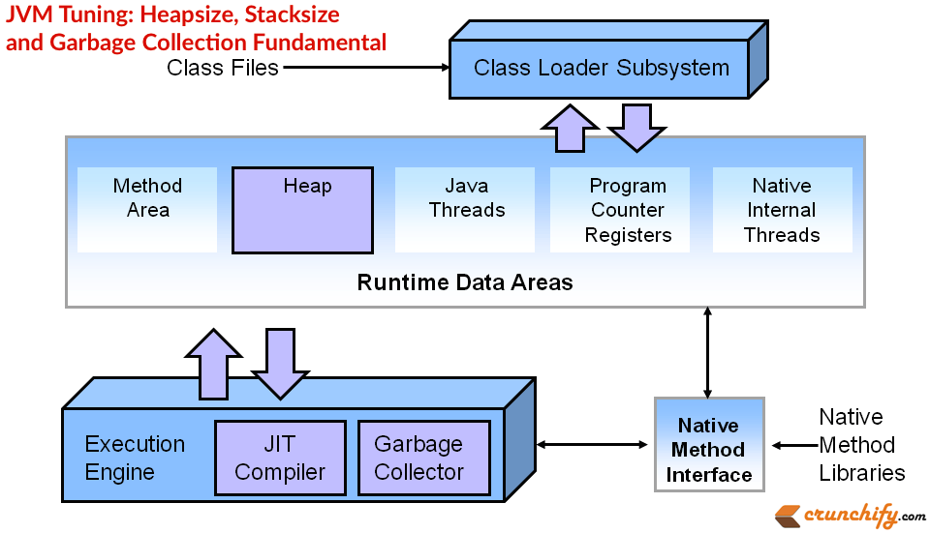

Heap Size:
When a Java program starts, Java Virtual Machine gets some memory from Operating System. Java Virtual Machine or JVM uses this memory for all its need and part of this memory is call java heap memory. Whenever we create object using new operator or by any another means object is allocated memory from Heap and When object dies or garbage collected, memory goes back to Heap space in Java.
Tutorial on Increase Eclipse Memory Size to avoid OOM on Startup.
JVM OPTION | MEANING
-Xms | initial java heap size
-Xmx | maximum java heap size
-Xmn | the size of the heap for the young generation
It is good practice for big production projects to set the minimum -Xms and maximum -Xmx heap sizes to the same value.
For efficient garbage collection, the -Xmn value should be lower than the -Xmx value. Heap size does not determine the amount of memory your process uses.
If you monitor your java process with an OS tool like top or task manager, you may see the amount of memory you use exceed the amount you have specified for -Xmx. -Xmx limits the java heap size, java will allocate memory for other things, including a stack for each thread. It is not unusual for the total memory consumption of the VM to exceed the value of -Xmx.

Stack Size:
Each thread in the VM get’s a stack. The stack size will limit the number of threads that you can have, too big of a stack size and you will run out of memory as each thread is allocated more memory than it needs.
JVM OPTION | MEANING
-Xss | the stack size for each thread
-Xss determines the size of the stack: –Xss1024k. If the stack space is too small, eventually you will see an exception class java.lang.StackOverflowError.

Garbage Collection:
There are essentially two GC threads running. One is a very lightweight thread which does “little” collections primarily on the Young generation of the heap. The other is the Full GC thread which traverses the entire heap when there is not enough memory left to allocate space for objects which get promoted from the Young to the older generation(s).
If there is a memory leak or inadequate heap allocated, eventually the older generation will start to run out of room causing the Full GC thread to run (nearly) continuously. Since this process stops the world, Java application won’t be able to respond to requests and they’ll start to back up or OOM.
The amount allocated for the Young(Eden) generation is the value specified with -Xmn. The amount allocated for the older generation is the value of -Xmx minus the -Xmn. Generally, you don’t want the Eden to be too big or it will take too long for the GC to look through it for space that can be reclaimed.

Basic WSDL Structure Understanding – (Web Service Description Language) Explained

Last Updated on 25 November, 2014 by App Shah 9 Comments

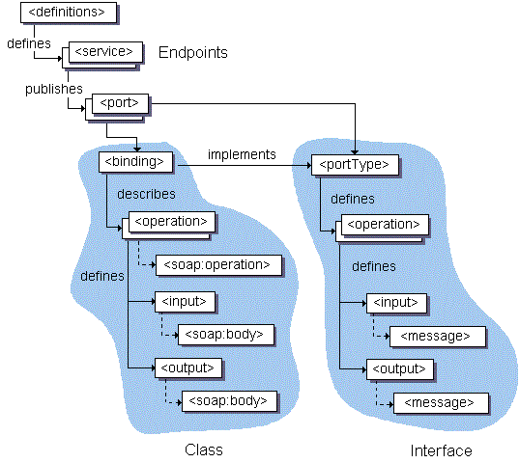
You may have seen my previous post on SOAP vs. REST call. Now a day companies are moving to REST service calls but still there are majority of companies still uses SOAP over REST. This tutorial explains basic of WSDL (Web Service Description Language).
If you have any of below question then you are at right place:
- What is Web Services Description Language (WSDL)?
- WSDL Tutorial
- Web Services Description Language (WSDL) Explained
- Examples of WSDL – Web Service Description Language

Web Services Description Language (WSDL)
In Java Web Development World, WSDL is an XML format for describing network services as a set of endpoints operating on messages containing either document-oriented or procedure-oriented information. The operations and messages are described abstractly, and then bound to a concrete network protocol and message format to define an endpoint. Related concrete endpoints are combined into abstract endpoints (services). WSDL is extensible to allow description of endpoints and their messages regardless of what message formats or network protocols are used to communicate, however, the only bindings described in this document describe how to use WSDL in conjunction with SOAP 1.1, HTTP GET/POST, and MIME.
Another must read:
- Create Sample WSDL in Eclipse and Generate Client
- How to build RESTful Service with Java using JAX-RS and Jersey (Example)
In other words: A WSDL document defines services as collections of network endpoints, or ports. In WSDL, the abstract definition of endpoints and messages is separated from their concrete network deployment or data format bindings. This allows the reuse of abstract definitions: messages, which are abstract descriptions of the data being exchanged, and port types which are abstract collections of operations. The concrete protocol and data format specifications for a particular port type constitutes a reusable binding. A port is defined by associating a network address with a reusable binding, and a collection of ports define a service. Hence, a WSDL document uses the following elements in the definition of network services:
- Types– a container for data type definitions using some type system (such as XSD).
- Message– an abstract, typed definition of the data being communicated.
- Operation– an abstract description of an action supported by the service.
- Port Type–an abstract set of operations supported by one or more endpoints.
- Binding– a concrete protocol and data format specification for a particular port type.
- Port– a single endpoint defined as a combination of a binding and a network address.
- Service– a collection of related endpoints.
Example: SOAP 1.1 Request/Response via HTTP
Sample WSDL File
1  2  3  4  5  6  7  8  9  10  11  12  13  14  15  16  17  18  19  20  21  22  23  24  25  26  27  28  29  30  31  32  33  34  35  36  37  38  39  40  41  42  43  44  45  46  47  48  49  50  51  52  53  54  55  56  57  58  59  60  61  62  63  64  65 | <?xml version="1.0"?>  <definitions name="StockQuote"  targetNamespace="http://example.com/stockquote.wsdl"  xmlns:tns="http://example.com/stockquote.wsdl"  xmlns:xsd1="http://example.com/stockquote.xsd"  xmlns:soap="http://schemas.xmlsoap.org/wsdl/soap/"  xmlns="http://schemas.xmlsoap.org/wsdl/">  <types>  <schema targetNamespace="http://example.com/stockquote.xsd"  xmlns="http://www.w3.org/2000/10/XMLSchema">  <element name="TradePriceRequest">  <complexType>  <all>  <element name="tickerSymbol" type="string"/>  </all>  </complexType>  </element>  <element name="TradePrice">  <complexType>  <all>  <element name="price" type="float"/>  </all>  </complexType>  </element>  </schema>  </types>  <message name="GetLastTradePriceInput">  <part name="body" element="xsd1:TradePriceRequest"/>  </message>  <message name="GetLastTradePriceOutput">  <part name="body" element="xsd1:TradePrice"/>  </message>  <portType name="StockQuotePortType">  <operation name="GetLastTradePrice">  <input message="tns:GetLastTradePriceInput"/>  <output message="tns:GetLastTradePriceOutput"/>  </operation>  </portType>  <binding name="StockQuoteSoapBinding" type="tns:StockQuotePortType">  <soap:binding style="document" transport="http://schemas.xmlsoap.org/soap/http"/>  <operation name="GetLastTradePrice">  <soap:operation soapAction="http://example.com/GetLastTradePrice"/>  <input>  <soap:body use="literal"/>  </input>  <output>  <soap:body use="literal"/>  </output>  </operation>  </binding>  <service name="StockQuoteService">  <documentation>My first service</documentation>  <port name="StockQuotePort" binding="tns:StockQuoteBinding">  <soap:address location="http://example.com/stockquote"/>  </port>  </service>  </definitions>
Factory Design Pattern explained with Example.

Java Collections – hashCode() and equals() – How to Override equals() and hashcode() Method in Java?
Last Updated on 10 December, 2014 by App Shah Leave a Comment
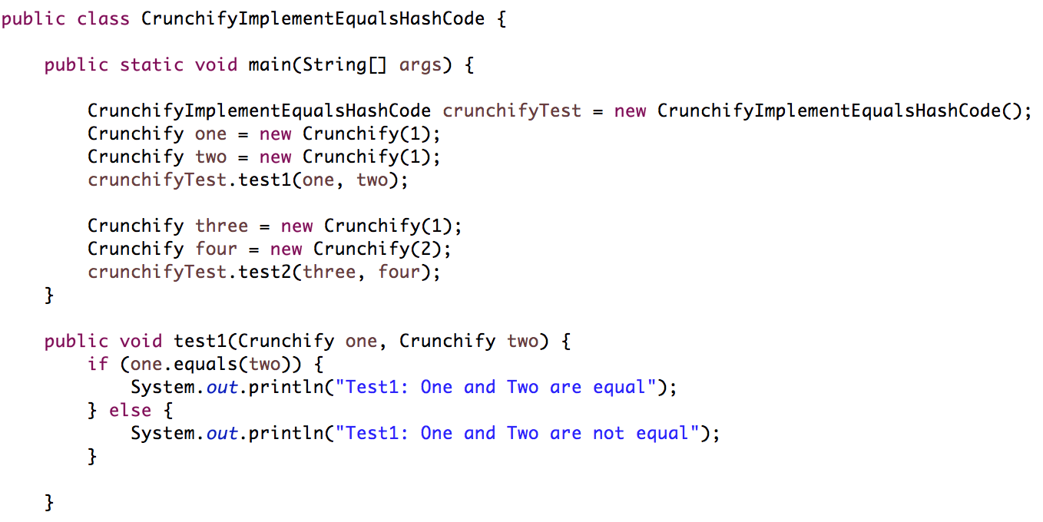
equals() and hashCode() in Java are two fundamental method which is declared in Object class and part or core Java library.
If you have any one of below concerns in Java then you are at correct place.
- Java Practices -> Implementing equals
- override – Overriding equals and hashCode in Java
- How to override equals() method in java
- How to override hashCode() method in java
- How to override equals and hashCode method in Java
- How and Why to Override the equals Method in Java
- Why always override hashcode() if overriding equals()?
Let’s take a look at simple example to understand first Reference Equality and Logical Equality. The equality operator (==) compares the references (addresses in memory) of the two Strings as two different numbers – this is known as Reference equality. Logical equality compares the data of the objects instead of the value of the references.
CrunchifyLogicalVsReferenceEqality.java
Java
1  2  3  4  5  6  7  8  9  10  11  12  13  14  15  16  17  18  19  20  21  22  23  24  25  26  27  28  29  30  31  32 | package com.crunchify.tutorials;  /**  * @author Crunchify.com  */  public class CrunchifyLogicalVsReferenceEqality {  public static void main(String[] args) {  String strA = new String("eBay");  String strB = new String("eBay");  String strC = new String("Paypal");  // Create a String reference and assign an existing String's reference to it  // so that both references point to the same String object in memory.  String strD = strA;  // Print out the results of various equality checks  // Reference Equality  System.out.println("Reference Equality Result:");  System.out.println(strA == strB);  System.out.println(strA == strC);  System.out.println(strA == strD);  // Logical Equality  System.out.println("\nLogical Equality Result:");  System.out.println(strA.equals(strB));  System.out.println(strA.equals(strC));  System.out.println(strA.equals(strD));  }  }
Output:
1  2  3  4  5  6  7  8  9 | Reference Equality Result:  false  false  true  Logical Equality Result:  true  false  true
hashCode and equals are closely related :
- if you override equals, you must override hashCode.
- hashCode must generate equal values for equal objects.
- equals and hashCode must depend on the same set of "significant" fields. You must use the same set of fields in both of these methods. You are not required to use all fields. For example, a calculated field that depends on others should very likely be omitted from equals and hashCode.
When implementing equals, fields are compared differently, according to their type:
- object fields, including collections : use equals
- type-safe enumerations : use either equals or == (they amount to the same thing, in this case)
- possibly-null object fields : use both == and equals
- array fields : use Arrays.equals
- primitive fields other than float or double : use ==
- float : convert to int using Float.floatToIntBits, then use ==
- double : convert to long using Double.doubleToLongBits, then use ==

Implementing hashCode :
- if a class overrides equals, it must override hashCode
- when they are both overridden, equals and hashCode must use the same set of fields
- if two objects are equal, then their hashCode values must be equal as well
- if the object is immutable, then hashCode is a candidate for caching and lazy initialization
It is a popular misconception that hashCode provides a unique identifier for an object. It does not.
By general contract, the equals() method in Java must be reflexive, symmetric, transitive, consistent, and any non-null reference must return false. In other words, for arbitrary values of a, b, and c, the following tests must always pass:
1  2  3  4  5  6  7  8  9  10  11  12  13  14  15  16 | / reflexive property  assertTrue( a.equals(a) );  // symmetric property  assertTrue( a.equals(b) == b.equals(a) );  // transitive property  if ( a.equals(b) && b.equals(c) ) {  assertTrue( a.equals(c) );  }  // consistency property  assertTrue( a.equals(b) == a.equals(b) );  // non-null property  assertFalse( a.equals(null) );
For the Best practice use below steps to implement your equals() method:
- Use this == that to check reference equality
- Use instanceof to test for correct argument type
- Cast the argument to the correct type
- Compare significant fields for equality
Complete Example:
CrunchifyImplementEquals.java
Java
1  2  3  4  5  6  7  8  9  10  11  12  13  14  15  16  17  18  19  20  21  22  23  24  25  26  27  28  29  30  31  32  33  34  35  36  37  38  39  40  41  42  43  44  45  46  47  48  49  50  51  52  53  54  55  56  57  58  59  60  61  62  63  64 | package com.crunchify.tutorials;  /**  * @author Crunchify.com  */  public class CrunchifyImplementEqualsHashCode {  public static void main(String[] args) {  CrunchifyImplementEqualsHashCode crunchifyTest = new CrunchifyImplementEqualsHashCode();  Crunchify one = new Crunchify(1);  Crunchify two = new Crunchify(1);  crunchifyTest.test1(one, two);  Crunchify three = new Crunchify(1);  Crunchify four = new Crunchify(2);  crunchifyTest.test2(three, four);  }  public void test1(Crunchify one, Crunchify two) {  if (one.equals(two)) {  System.out.println("Test1: One and Two are equal");  } else {  System.out.println("Test1: One and Two are not equal");  }  }  public void test2(Crunchify three, Crunchify four) {  if (three.equals(four)) {  System.out.println("Test2: Three and Four are equal");  } else {  System.out.println("Test2: Three and Four are not equal");  }  }  }  class Crunchify {  private int value;  Crunchify(int val) {  value = val;  }  public int getValue() {  return value;  }  @Override  public boolean equals(Object o) {  if ((o instanceof Crunchify) && (((Crunchify) o).getValue() == this.value)) {  return true;  } else {  return false;  }  }  @Override  public int hashCode() {  int result = 0;  result = (int) (value / 11);  return result;  }  }
Output:
1  2 | Test1: One and Two are equal  Test2: Three and Four are not equal

Java Iterator, ListIterator fundamentals and ConcurrentModificationException

Last Updated on 10 October, 2016 by App Shah 2 Comments
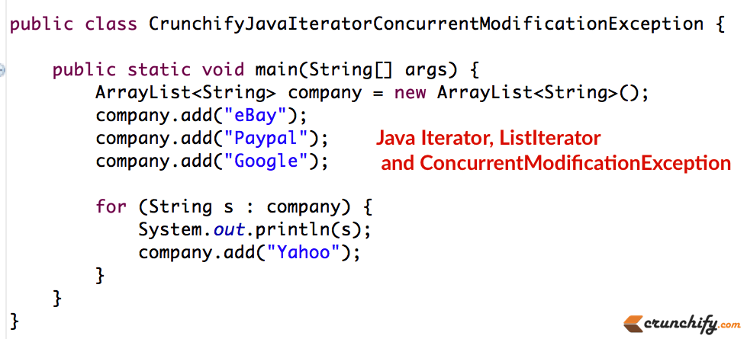
Do you have these questions?
- Java – how to avoid ConcurrentModificationException
- concurrentmodificationexception iterator next
- concurrent modification exception in java hashmap
In previous topic we learn how to iterate through Java Collection class ArrayList. Also used best practice to avoid possible Out Of Memory (OOM) situation.
In this tutorial we will see some basic fundamentals of Java Iterator and possible ConcurrentModificationException.
Introduced in the Java JDK 1.2 release, the java.util.Iterator interface allows the iteration of Collection classes. Each Iterator provides a next() and hasNext() method, and may optionally support a remove() method. Iterators are created by the corresponding container class, typically by a method named iterator(). It is an improvement over Enumeration interface.

Iterator Methods
Iterator defines three methods, one of which is optional.
RESULT | METHOD | DESCRIPTION
b = | it.hasNext() | true if there are more elements for the iterator.
obj = | it.next() | Returns the next object. If a generic list is being accessed, the iterator will return something of the list’s type. Pre-generic Java iterators always returned type Object, so a downcast was usually required.
 | it.remove() | Removes the most recent element that was returned by next. Not all collections support delete. An UnsupportedOperationException will be thrown if the collection does not support remove().

Important points:
- Iterators are unidirectional. We can iterate only in one direction.
- Iteration can be done only once. If you reach the end of series its done. If we need to iterate again we should get a new Iterator.

Difference between Iterator and Enumeration interfaces
- remove() method is introduced in iterator. Using this method we can remove element from the underlying collection which we are iterating.
- Enumeration has two methods and both are available in iterator. Method names for both of them are shortened.

ListIterator methods
ListIterator is implemented only by the classes that implement the List interface (ArrayList, LinkedList, and Vector). ListIterator provides the following.
RESULT | METHOD | DESCRIPTION
Forward iteration
b = | it.hasNext() | true if there is a next element in the collection.
obj = | it.next() | Returns the next object.
Backward iteration
b = | it.hasPrevious() | true if there is a previous element.
obj = | it.previous() | Returns the previous element.
Getting the index of an element
i = | it.nextIndex() | Returns index of element that would be returned by subsequent call to next().
i = | it.previousIndex() | Returns index of element that would be returned by subsequent call to previous().
Optional modification methods. UnsupportedOperationException thrown if unsupported.
 | it.add(obj) | Inserts obj in collection before the next element to be returned by next() and after an element that would be returned by previous().
 | it.set() | Replaces the most recent element that was returned by next or previous().
 | it.remove() | Removes the most recent element that was returned by next() or previous().

ConcurrentModificationException Basic
We cannot add or remove elements to the underlying collection when we are using an iterator.
CrunchifyJavaIteratorConcurrentModificationException.java
Java
1  2  3  4  5  6  7  8  9  10  11  12  13  14  15  16  17  18  19  20  21  22  23 | package crunchify.com.tutorial;  import java.util.ArrayList;  /**  * @author Crunchify.com  *  */  public class CrunchifyJavaIteratorConcurrentModificationException {  public static void main(String[] args) {  ArrayList<String> company = new ArrayList();  company.add("eBay");  company.add("Paypal");  company.add("Google");  for (String s : company) {  System.out.println(s);  company.add("Yahoo");  }  }  }

Eclipse Console Output:

Have you noticed Race Condition in Java Multi-threading Concurrency Example? How to deal with it?
Last Updated on 11 March, 2015 by App Shah 4 Comments
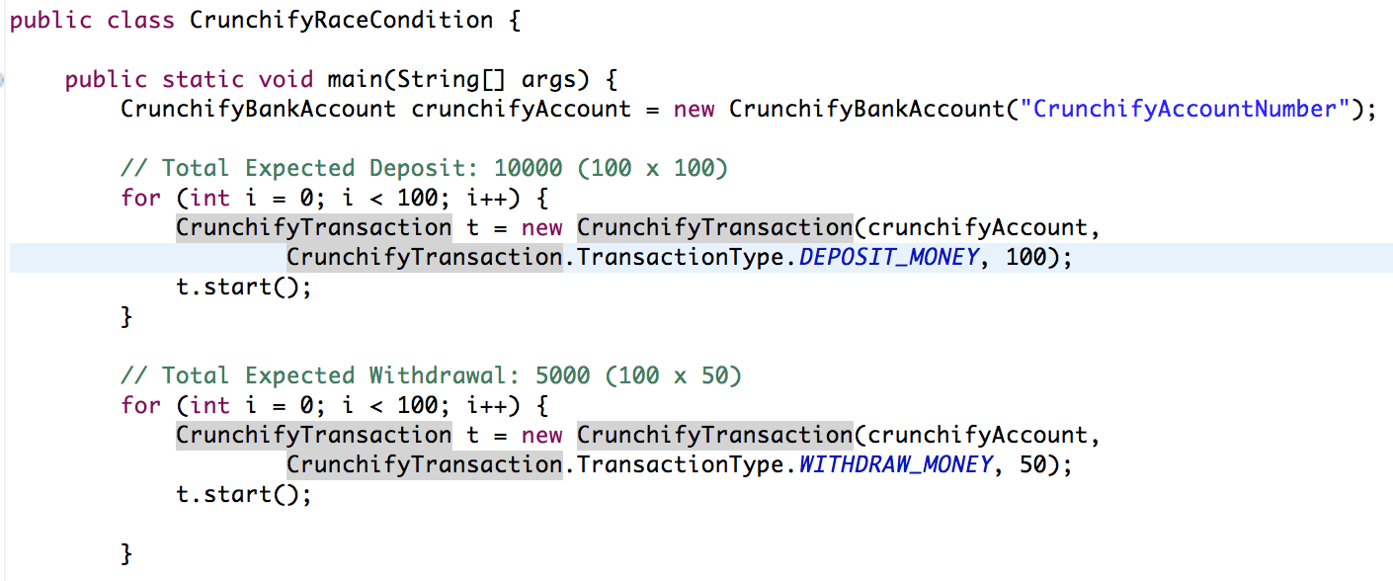
Sometime back I’ve written an articled on Producer Consumer Example and how to handle read write better way. On the similar note, in this tutorial we will discuss something on Race Condition and Thread locking.
If you have any of below questions then you are at right place:
- Java race condition example
- mutex java example
- multithreading – What is a race condition?
- Race Conditions and Critical Sections
- What is race condition?
- How to deal with Race Condition in Java with Example
Race condition in Java occurs when two or more threads try to modify/update shared data at the same time. Let’s take a look at below example.

Program logic:
This is very simple banking example in which you will deposit and withdraw amounts 100 times. You will deposit $100 total 100 times = $100 x 100 = $10,000 and you will withdraw $50 total 100 times = $50 x 100 = $5,000. At the end of program completion you should have $5000 in your bank.

Here are the steps:
- Create class CrunchifyRaceCondition.java
- Create class CrunchifyTransaction.java
- Create class CrunchifyBankAccount.java
- We will run class CrunchifyRaceCondition and it will start deposit and withdraw loop 100 times.
- We will run it with Synchronized block to check result
- We will run it without Synchronized block to check result
CrunchifyRaceCondition.java
Java
1  2  3  4  5  6  7  8  9  10  11  12  13  14  15  16  17  18  19  20  21  22  23  24  25  26  27  28  29  30  31  32  33  34  35  36 | package com.crunchify.tutorial;  /**  * @author Crunchify.com  *  */  public class CrunchifyRaceCondition {  public static void main(String[] args) {  CrunchifyBankAccount crunchifyAccount = new CrunchifyBankAccount("CrunchifyAccountNumber");  // Total Expected Deposit: 10000 (100 x 100)  for (int i = 0; i < 100; i++) {  CrunchifyTransaction t = new CrunchifyTransaction(crunchifyAccount, CrunchifyTransaction.TransactionType.DEPOSIT_MONEY, 100);  t.start();  }  // Total Expected Withdrawal: 5000 (100 x 50)  for (int i = 0; i < 100; i++) {  CrunchifyTransaction t = new CrunchifyTransaction(crunchifyAccount, CrunchifyTransaction.TransactionType.WITHDRAW_MONEY, 50);  t.start();  }  // Let's just wait for a second to make sure all thread execution completes.  try {  Thread.sleep(1000);  } catch (InterruptedException e) {  System.out.println(e);  }  // Expected account balance is 5000  System.out.println("Final Account Balance: " + crunchifyAccount.getAccountBalance());  }  }
CrunchifyTransaction.java
Java
1  2  3  4  5  6  7  8  9  10  11  12  13  14  15  16  17  18  19  20  21  22  23  24  25  26  27  28  29  30  31  32  33  34  35  36  37  38  39  40  41  42  43  44  45  46  47  48  49  50  51  52  53  54  55  56 | package com.crunchify.tutorial;  /**  * @author Crunchify.com  */  class CrunchifyTransaction extends Thread {  public static enum TransactionType {  DEPOSIT_MONEY(1), WITHDRAW_MONEY(2);  private TransactionType(int value) {  }  };  private TransactionType transactionType;  private CrunchifyBankAccount crunchifyAccount;  private double crunchifyAmount;  /*  * If transactionType == 1, depositAmount() else if transactionType == 2 withdrawAmount()  */  public CrunchifyTransaction(CrunchifyBankAccount crunchifyAccount, TransactionType transactionType, double crunchifyAmount) {  this.transactionType = transactionType;  this.crunchifyAccount = crunchifyAccount;  this.crunchifyAmount = crunchifyAmount;  }  public void run() {  switch (this.transactionType) {  case DEPOSIT_MONEY:  depositAmount();  printBalance();  break;  case WITHDRAW_MONEY:  withdrawAmount();  printBalance();  break;  default:  System.out.println("NOT A VALID TRANSACTION");  }  }  public void depositAmount() {  this.crunchifyAccount.depositAmount(this.crunchifyAmount);  }  public void withdrawAmount() {  this.crunchifyAccount.withdrawAmount(crunchifyAmount);  }  public void printBalance() {  System.out.println(Thread.currentThread().getName() + " : TransactionType: " + this.transactionType + ", Amount: " + this.crunchifyAmount);  System.out.println("New Account Balance: " + this.crunchifyAccount.getAccountBalance());  }  }
CrunchifyBankAccount.java
Java
1  2  3  4  5  6  7  8  9  10  11  12  13  14  15  16  17  18  19  20  21  22  23  24  25  26  27  28  29  30  31  32  33  34  35  36  37  38  39  40  41  42 | package com.crunchify.tutorial;  /**  * @author Crunchify.com  */  class CrunchifyBankAccount {  private String crunchifyAccountNumber;  private double crunchifyAccountBalance;  public String getAccountNumber() {  return crunchifyAccountNumber;  }  public double getAccountBalance() {  return crunchifyAccountBalance;  }  public CrunchifyBankAccount(String crunchifyAccountNumber) {  this.crunchifyAccountNumber = crunchifyAccountNumber;  }  // Make a note of this line -- synchronized keyword added  public synchronized boolean depositAmount(double amount) {  if (amount < 0) {  return false;  } else {  crunchifyAccountBalance = crunchifyAccountBalance + amount;  return true;  }  }  // Make a note of this line -- synchronized keyword added  public synchronized boolean withdrawAmount(double amount) {  if (amount > crunchifyAccountBalance) {  return false;  } else {  crunchifyAccountBalance = crunchifyAccountBalance - amount;  return true;  }  }  }
Please check line 24 and 34 above. Keep that Synchronized keyword and run your program. You should see correct result as you see it in below image.
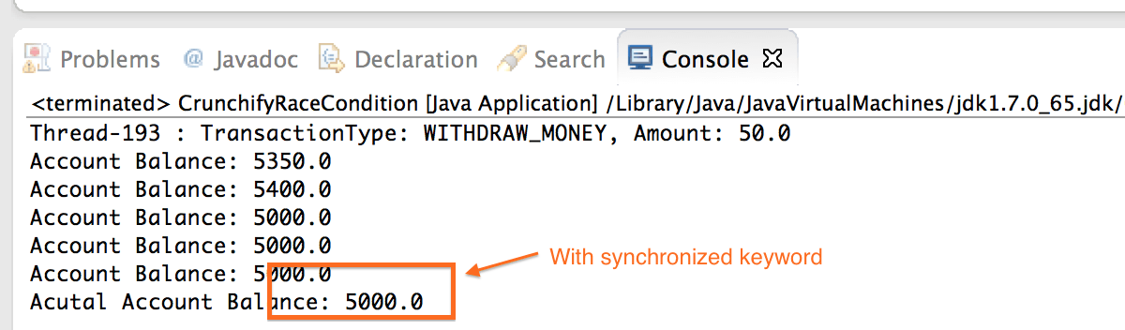
Now remove synchronized keyword from line 24 and 34 and run the same program. You may need to run this program multiple times to see an issue. In java there is no guarantee you will see Race condition all the times.
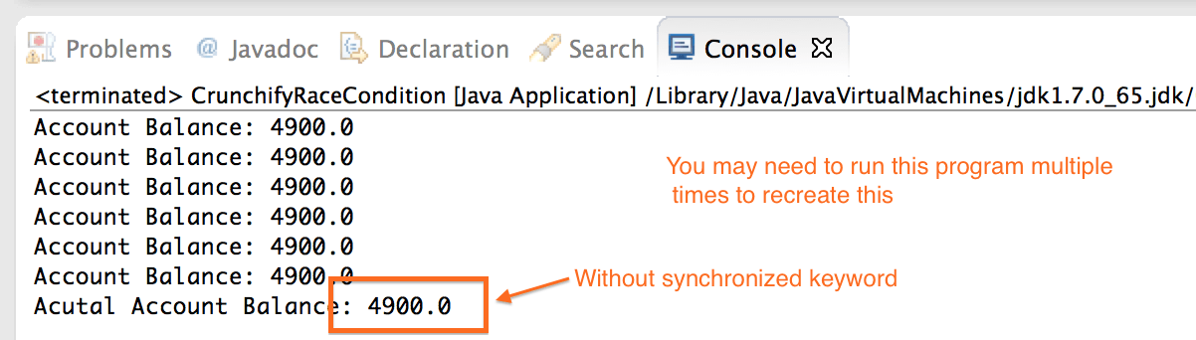
If you have enterprise level application and you are talking of millions of transaction per seconds then race condition may cause disaster for your company.

Now question is how to avoid Race Condition in your Java Application?
- If the race condition is in updates to some shared in-memory data structures, you need to synchronize access and updates to the data structure appropriate way.
- If the race condition is in updates to the your database, you need to restructure your SQL to use transactions at the appropriate level of granularity.
- It’s not a bad idea to do Load testing before going live in production. More load may cause rare Race Condition. Better to fix it before rather fixing it later.
- Make sure you have no global variable that you write to.
- In Java, every object has one and only one monitor and mutex associated with it. The single monitor has several doors into it, however, each indicated by the synchronized keyword. When a thread passes over the synchronized keyword, it effectively locks all the doors.
- Of course, if a thread doesn’t pass across the synchronized keyword, it hasn’t locked the door, and some other thread is free barge in at any time.

